Author: Lady Gwenhwyfar Weale (Jennifer Erna Covel)
Contact: gwenhwyfarweale@gmail.com
Delivered: June 15, 2019

Family Sagas of Iceland:

A Focus on Egil’s Saga and The Saga of Burnt Njál

Introduction
Milan Kundera is often quoted often in reference to the Icelandic Sagas, “I donʼt mean to say that the sagas have been forgotten—after centuries of indifference they are now being studied in universities throughout the world —but they belong to the “archeology of letters,” they do not influence living literature.” This class would argue against resigning the Icelandic Sagas to the “archeology of letters” and show that contrary to Kundera’s statement, the sagas have had and can influence living people and contemporary culture.

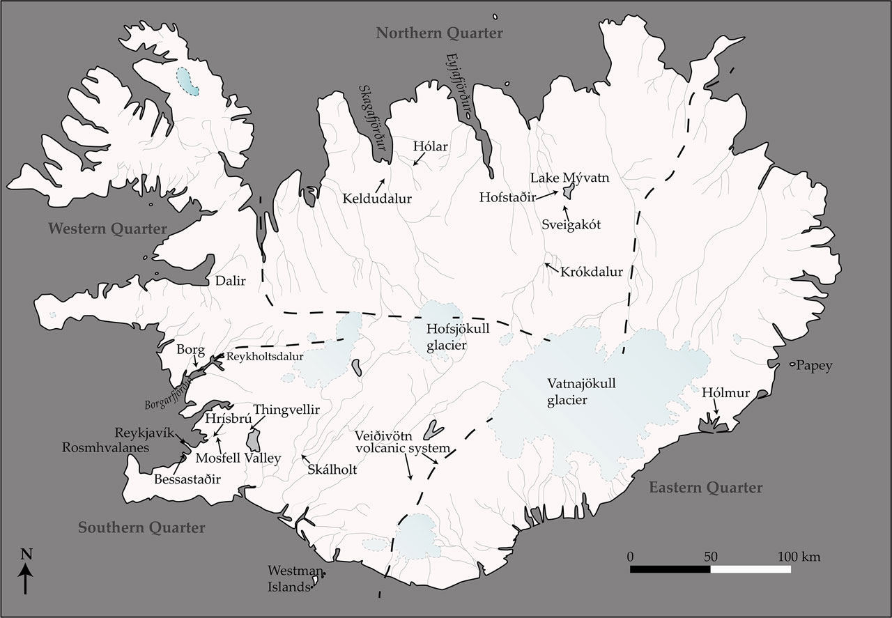
A map of the quarters of Medival Iceland

HISTORical Background
Before we dive into the literature, it is helpful to know who the Icelanders were and when the Vikings of Iceland were active. A good deal of what we know about Iceland’s early history came from Ari Thorgilsson, who is considered the father of Icelandic history.

The settlement of Iceland took place in 870 and it was the last land in which Norsemen made a permanent settlement. Details about the settling of Iceland can be found in the Landnámabók, a collection of historical stories.

The first successful settler was Ingólfr of Western Norway.

Many of the settlers fled Norway to escape from Haraldr Fair Hair (or Fine Hair), the first prince to submit all of Norway to his authority as of 885.

Some of the settlers came from Norse colonists that had married women from the British Isles, Ireland, and the Hebrides.

The Chieftains that settled in Iceland ruled without a central government.

They would meet during the year to attend regional Things to trade, socialize, and deal with matters of law.

Once a year they would gather at the Althing, the largest judicial and social event.

The Age of the Vikings (the Saga Age) lasted roughly two hundred years.

The first notable Viking attack took place in Lindesfarm in 793 according to the Anglo-Saxon Chronicle.

By 1000 many Norsemen converted to Christianity, making raiding other Christians a difficult prospect. The process of conversion is detailed in multiple sagas including The Greater Saga of Ólafr Tryggvason, Kristni Saga, Laxdœla Saga, the Voluspá, and of course, the Íslendigabok. Many other sagas include a conversion narrative that introduces this particular cultural shift and its impact.

The conversion of Iceland was piecemeal as, “Some of the early Icelanders found less difficulty[…]in combining Christianity with pagan beliefs.” (Turville-Petre 49)

“It is not surprising that people whose religious beliefs were so ill defined as those of the Icelanders should take no pains to propagate them, and should seldom defend them with violence, for they did not believe that salvation depended upon them. (Turville-Petre 50)

The first attempt to convert Icelanders was made between 981-985 by an Icelander, Thorvadir but his efforts were unsuccessful.

King Ólafr Tryggvason was determined to Christianize not just Norway in 955 but all of its trading partners as well.

In 996, Ólafr sent Stefnir Thorgilsson to convert Icelanders to Christianity but he only strengthened the pagan opposition.

Ólafr then sought to convert Icelanders that visited Norway.

Thangbrandr’s mission to convert Icelanders had a bit more success as he converted Gizurr the White (mentioned in Njála Saga) and Hjalti Skeggjason. They then pushed for the Christianization of Iceland and Christian law was integrated with pagan law at an Althing in 1000.

In 1263, Iceland became subject to the Crown of Norway.

Family SAGA Charactersitics and History
Like all forms of literature, the family sagas have distinct characteristics that separate them from other types of literature. The term saga refers to not just the work as a whole but the story that takes place within it.

Basic Saga Facts

Current evidence indicates that there were over forty different family sagas recorded.

They were composed mainly in the 13th and 14th centuries but they concern Norse characters from three hundred years earlier.

The single largest and most valuable collection of Islendinga Sogur is a mid- fourteenth-century manuscript known as Modruvallabok, which contains two hundred vellum leaves and eleven sagas.

What were the character types?

These are the stories of farmers and the characters are largely every-day people.

They do not feature kings and queens as main protagonists, though they may appear in some sagas as secondary characters.

However, common-place individuals are noted to have almost supernatural abilities.

Despite the appearance of realism, the sagas can and often do include trolls, ghosts, berserks, prophecy speakers, and magical enchantments.

“The sagas of Icelanders may be classified as containing the same type of realism that occurs in modern fantastic fiction: what is now referred to as the supernatural is far from excluded narrative” (Jakobsson 2).

“For those who believe in trolls, the appearance of a troll hardly makes a narrative less realistic and the idea that the demarcation between the natural and the supernatural can be clearly defined does not seem applicable to a medieval text such as a saga.” Jakobsson 3).

They feature women with agency.

There is use of the term, skorungur, which translates to mean a woman of strong character.

This includes women of Burning Njal who set the saga in motion in a feud over priority seating at a feast.

“Egil fears no adversary, he is timid and submissive towards women, as shown by his almost blushing love for his brother’s widow Asgerd, who later becomes his wife, and by the way he allows his daughter Thorgerd “to trick him out of his sympathy-seeking act of pining away after the death of his sons” (Smiley 76)

What are the literary characteristics?

The narrative style is very stripped down and the language plain.

They were written in prose rather than verse. However, many of the sagas include verse within them. And this verse is typically depicted as a part of the dialogue.

The family sagas focus on the individual and social consequences of conflict.

Though there is a lot of human drama involved, at no point do the authors pretend to imagine how the characters are feeling or what they are thinking.

The character’s reactions are described through their actions.

There is no omniscient storyteller revealing a character’s inner thoughts or feelings.

The stories focus on elements of legal, moral, and political life.

The anonymity of authors is a feature, not bug, of the saga style.

Egil’s Saga
Egil’s Saga is entirely biographical and stands aside from the other Icelandic family Sagas in that Egil was a poet as well as an adventurer and his prolific verse fills his story. “He [Egil] takes after the great god [Odin] as a poet, a warrior, and a finder of ways” (de Looze 9). Unlike many of his contemporaries and all of his victims, Egil lives to die of old age and in is bed.

The Protagonist

Egil Skallagrimsson is an impressive figure of a man and has many unusual attributes. His childhood is rather exceptional in that an alarmingly young age he performs the deeds that would characterize his whole life.

At the age of three he composes his first poem and it is at a feast at Yngvar’s farm (Smiley 136).

At the age of seven he commits his first murder and he kills a child that is both older and stronger than he is with an axe (Smiley 149).

Egil’s advanced behavior in youth is not surprising when one considers that his entire lineage in many places were seemingly more than human. This could be more metaphorical than literal, but the comparisons stand. Egil himself is described as, ““as huge as a troll” (Smiley 220)

“There was a man named Ulf, the son of Bjalfi and of Hallbera, the daughter of Ulf the Fearless. She was the sister of Hallbjorn Half-troll from Hrafnista, the father of Ketil Haeng” (Smiley 77).

Egil’s great-grandfather is depicted as, “People claimed he was a shape-shifter and they called him Kveldulf (Night Wolf)” (Smiley 77).

“They were known as Thorarna’s sons – she lived near Skallagrim and was a sorceress. Hobbler was a coal-biter. Other men in the band were Thorir the Giant and his brother Thorgeir Earth-long, a hermit called Odd and a freedman named Gris. In all there were twelve in the party, all outstandingly powerful men, and many of them were shape-shifters” (Smiley 120).

Egil himself is described as, ““as huge as a troll” (Smiley 220)

Structure

As divided by scholar Torfi H. Tulinius, Egil’s Saga can be split into two parts (de Looze 30).

The first part concerns itself with Thorolf Kveldufsson, Ketil Haeng, and Skallagrim. This includes chapters one through thirty.

The second part consists of Thorolf Skallagrimsson, Ketil Blund, Egil’s Overseas Journeys, and Egil’s Retirement from Traveling.

Egil and Eirik Blood-axe, Son of Haraldr Fair Hair, King of Norway and Subsequently Northumbria

In the course of the saga, Egil marries his brother’s widow, Asgerd, after his brother is slain in a battle in England.

Egil was made to understand that he would also be receiving a substantial amount of wealth with her.

This leads to a dispute with Eirik Blood-axe and Egil killing Eirik’s son.

Later, Egil is washed upon the shores of Northumbria.

Once in Eirik’s court he must save himself through poetry, constructing a facetious praise-poem dedicated to Eirik, who seems oblivious to Egil’s sarcasm.

This famous poem is known as Hofudlausn or Head-ransom.

Saga of Burning Njal
The Njála Saga or The Saga of Burnt Njál (Brennu-Njáls Saga) is a unique literary achievement of Medieval literature. The saga largely revolves around the conflict between two families, the Thorgerssons and the Hámundarsons. Up until the start of the feud, they are allies and friends.

The Protagonists

Who are the men?

Njála Thorgersson is a land owner, politician, and lawyer.

He is a wealthy, well-connected land owner.

He is experienced in writing law and manipulating it to achieve his goals.

He is so wise that he often sits council to others.

Gunnarr Hámundarson is an adventurer.

He is good looking to a fault and an excellent fighter.

He is successful and is envied by many.

He becomes engaged to and marries Hallgerd, against Njál’s advice.

What of the women?

Bergthora offers council to her husband, Njál.

She is knowledgeable and strong-willed.

She is not above using her intellect and will to get what she wants, even if it means goading and shaming the men in her life to take action.

Hallgerd, at the beginning of the saga, marries Gunnarr.

She immediately sparks a feud between the two families.

Is thrice widowed by the end of the saga.

Where and when did the action take place?

The events take place in Iceland between 930 and 1030.

While some of the action takes place on roads and in farms, the crucial events occur at Things.

Is Njála Saga Fact or Fiction?

Njal and Gunnarr, the two principles, are individuals that likely actually existed; they, and their feud, are referenced by other sagas.

The creative elements, or purposeful literary styling of Njála craft a very intentional narrative.

The dialogue is impactful.

The action sequences and pacing are on par with Medieval storytelling.

There are also occurrences and descriptions of individuals and actions that to a modern audience seem supernatural.

Gunnarr’s incredible feats of athletic prowess is the stuff of a modern-day Marvel Avenger.

Njál’s prescience is uncanny as he seems to be able to predict events before they even happen.

“Njal predicts she [Hallgerd] will be nothing but trouble.” (Miller 10).

“Njal councils him [Gunnarr] not to kill twice in the same linage, and to make ure he honors any settlement resolving matters should he violate the first of these admonitions” (Miller 11).

THE SAGA IN POPULAR CULTURE
As mentioned previously, in contrast to Kundera’s statement, the Icelandic sagas are alive and well in popular culture. In television, graphic novels, and literary fiction the characters, themes, and motifs of the Icelandic sagas are alive and well.

There are multiple modern television programs that have saga-esque characteristics to them and they are:

Discovery Channel’s The Vikings, and

The Last Kingdom based off of the Saxon Stories by Bernard Cornwell produced by the BBC.

There are modern-day authors writing fiction in the Icelandic saga style.

Linnea Hartsuyker has written two novels featuring a saga-style of story setting and telling and they are:

The Half-Drowned King, and

The Sea Queen.

Author Scott Oden’s Grimnir books feature a troll-like character similar to that of Egil (though it does not take place in Iceland) and they are:

A Gathering of Ravens, and

Twilight of the Gods.

The graphic novel Northlanders is an American comic book written by Brian Wood and is told in a saga-style though some of the action does not take place in Iceland and the volumes are:

The Anglo-Saxon Saga,

The Icelandic Saga, and

The European Saga.

Works Cited
De Looze, Laurence, et al. Egil, the Viking Poet. Toronto, University of Toronto Press, 2015
Jakobsson, Ármann. “Beast and Man: Realism and the Occult in ‘Egils Saga’.” Scandinavian Studies, Vol. 83, No. 1 (Spring 2011), pp. 29-44
Miller, William Ian, “Why is Your Axe Bloody?”. Oxford, Oxford University Press, 2016
Smiley, Jane, The Sagas of the Icelanders. New York, Penguin, 2001
Turville-Petre, G. The Origins of Icelandic Literature. Oxford, Clarendon Press, 1953

