Author: Lady Gwenhwyfar Weale (Jennifer Erna Covel)
Delivered: February 2, 2019

Icelandic Sagas: A Focus on Njála Saga

Introduction

The Njála Saga or The Saga of Burnt Njál (Brennu-Njáls Saga) is a unique literary achievement of Medieval literature. This class will focus on Njála’s place in Icelandic literature and storytelling. It will include a brief outline of the plot and some of the most vital characters. This class will also focus on the role of law, religion, the culture of feuding that existed in Iceland between 960 and 1020, and the supernatural.

History of the Manuscript
The author of Njála Saga is unknown, although there is much conjecture. The saga exists in roughly sixty different manuscripts. Twenty-one of these manuscripts are parchment and date from 1300-1600 but none of them contain the whole saga.

The fragments that contain the majority of the saga are:

The Reykjabók (AM 468 4to), c. 1300-1325.

The Gráskinna (GKS 2870), c. 1300 and with additions from c. 1500-1550.

The Möðruvallabók (AM 132 fol.), c. 1330-1370.

The Kálfalækjarbók (AM 133 fol.), c. 1350.

The Skafinskinna (GKS 2868 4to), c. 1350-1400

The Oddabók (AM 466 4to), c. 1460.

Where and when did the action take place?

The events take place in Iceland between 930 and 1030.

While some of the action takes place on roads and in farms, the crucial events occur at Things.

Things met at fixed times in fixed locations.

The Althing was established in Thingvellier and was held annually for two weeks during mid-summer.

Is Njála Saga Fact or Fiction?

Njal and Gunnarr, the two principles, are individuals that likely actually existed; they, and their feud, are referenced by other sagas.

The creative elements, or purposeful literary styling of Njála craft a very intentional narrative.

The dialogue is impactful.

The action sequences and pacing are on par with Medieval storytelling.

There are also occurrences and descriptions of individuals and actions that to a modern audience seem supernatural.

Gunnarr’s incredible feats of athletic prowess is the stuff of a modern-day avenger.

Njál’s prescience is uncanny.

Njála Structure
This particular saga falls under the category of a family saga, meaning, that it focuses upon one (or two) families and the drama that surrounds them.

Njála is expansive with a large amount of characters and in actual length.

The saga names over six hundred individuals.

Over a hundred have dialogue.

The rest of the individuals are largely referential and mentioned in reference to genealogy.

There are 159 chapters, in total, making it one of the longest sagas on record.

There are nine marriages but four are less than successful.

Two of them end in divorce.

Two of them end in death by axe.

Njála includes a conversion narrative, that sets up the martyr-like death scene.

Njál and his wife’s bodies miraculously survive the fire that kills them.

It gives a background and religious setting for the anti-burner group that wishes to condemn the burners and seek justice.

CHaracters
It tells the story of the feud between wives that consumes the extended families and allies of the Thorgerssons and Hámundarsons. Up until the start of the feud, they are allies and friends.

Who are the men?

Njála Thorgersson is a land owner, politician, and lawyer.

He is a wealthy, well-connected land owner.

He is experienced in writing law and manipulating it to achieve his goals.

He is so wise that he often sits council to others.

Gunnarr Hámundarson is an adventurer.

He is good looking to a fault and an excellent fighter.

He is successful and is envied by many.

He becomes engaged to and marries Hallgerd, against Njál’s advice.

What of the women?

Bergthora offers council to her husband, Njál.

She is knowledgeable and strong-willed.

She is not above using her intellect and will to get what she wants, even if it means goading and shaming the men in her life to take action.

Hallgerd, at the beginning of the saga, marries Gunnarr.

She immediately sparks a feud between the two families.

Is thrice widowed by the end of the saga, each husband having slapped her for a different reason.

The first husband she really wanted dead and this happens pre-feud.

The second she did not necessarily wish slain.

Gunnarr, in the progress of the narrative questions her judgement and slaps her, causing her to curse him.

Addressing a wrong
In the society depicted in Njála there are a few different ways to handle an injustice.

The wronged individual could do nothing.

This is seen as a regrettable but understandable choice if the wronged party has no money, connections, or political clout.

One would also need to consider the status of the involved individuals.

Are they a freeman?

Are they a slave?

The parties could mutually address the situation.

In one instance the case would be brought to individuals meant to mediate and arbitrate for their respective sides.

The parties could decide to settle the case personally and present their agreement to the arbitrators to formalize it.

Njál and Gunnarr often take this route during the course of the feud.

The wronged party could attempt to get a judgement that would lead to the opposing individual(s) to be declared outlaw.

The proclaimed outlaw would then have to be pursued until death.

Naturally, this could be a dangerous thing to attempt.

If the blood is still fresh, immediate retribution could be had but actions would likely later have to be resolved at a Thing in front of a Lawspeaker.

There was a time-limit imposed between the initial murder and the corresponding retribution.

If the blood had gone cold, an outlaw judgement would have to be attained before vengeance could be satisfied.

HOw and How Not to Feud
Bergthora and Hallgerd are the engines of strife in Njála. Initially, the fire of the feud is sparked over a seating arrangement at a feast.

The killings, while they initially start out small, increase in size and in the importance of the individuals slain.

Njál and Gunnarr have no sooner settled the last exchange of blood than they are confronted with another.

Eventually the feud hits the point of no return, and Bergthora’s sons and Hallgerd’s family become so acrimonious that the resentment trickles down generations and to extended family.

While the friendship of Gunnarr and Njál survive all of this, the feud has unintended consequences.

After a series of killings, he was judged banished for three years but Gunnarr does not leave Iceland.

His wife refuses him her hair to use as a bow-string.

Gunnar is slain by Gizur the White.

A series of marriages and killings set in place by machinations of the previous feud lead Flosi to murder Njál, his wife, their sons, and other household members.

They are burned alive in the farmhouse where they make their last stand.

Njál and his wife are found after the fire in their bed, covered with an ox hide that miraculously preserves their bodies from the flame leaving them dead but unburnt.

Suggested Reading

Allen, Richard, Fire and Iron: Critical Approaches to Njáls Saga

Anderson, Theodore, The Growth of the Medieval Icelandic Sagas (1180-1280)

Gueber, H.A., Myths of the Norsemen from the Eddas and the Sagas

Magnusson, Magnus and Palsson, Hermann, Njal’s Saga

Miller, William Ian, “Why is Your Axe Bloody?”

Oinas, Felix J., Heroic Epic and Saga

Smiley, Jane, The Sagas of the Icelanders

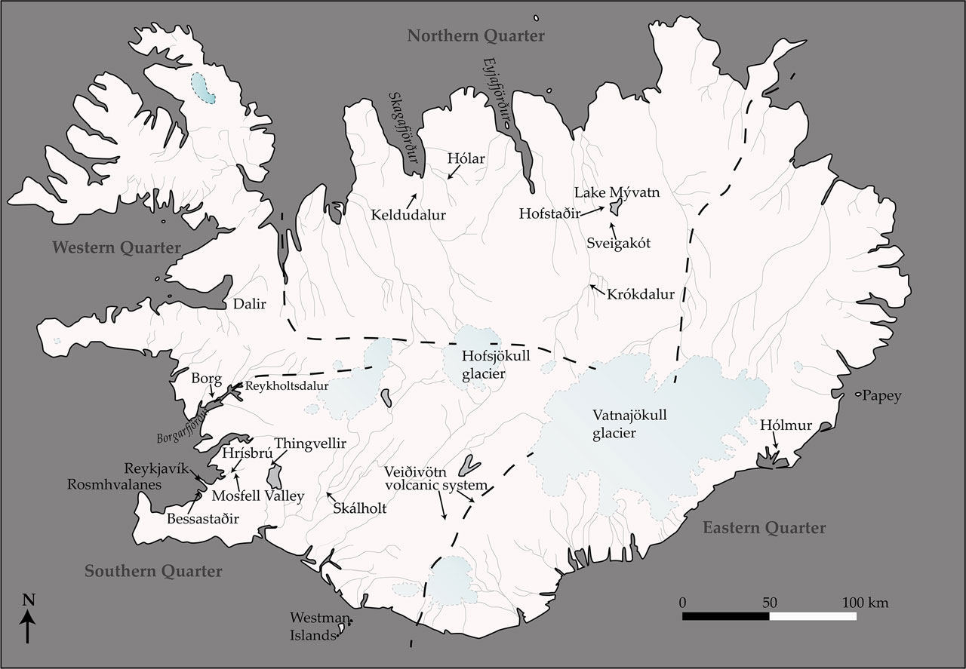
A map of the quarters of Medival Iceland

